Instructions for Outlook (desktop version)
- Go to Outlook on your desktop and open the calendar
- Copy the following .ics link

https://outlook.office365.com/owa/calendar/dbd6d704d32c40c29b6ca42cbb5d94ba@oregonstate.edu/cef900a3a41642cbbe02b0ca25b157a99720556416781562630/calendar.ics

- Click “Add Calendar” on your navigation bar. In other versions of Outlook, this will be “Open Calendar” (or “Manage Calendar” on your navigation bar then “Open Calendar)
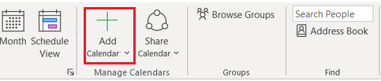
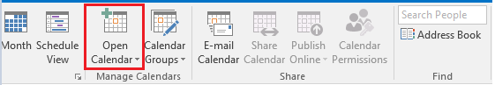
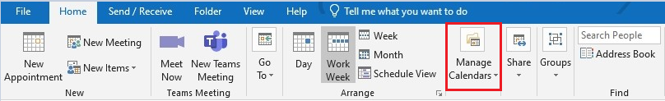
- Click “From Internet”
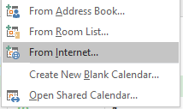
- Paste the .ics link into the subscription field
- After adding the link, confirm by clicking ‘Yes’
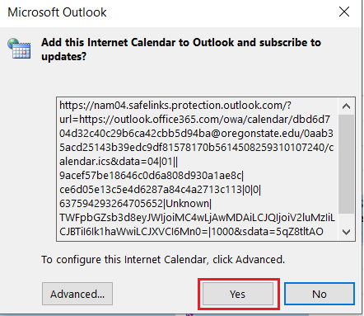
- If you see the Academic Calendar on the left-hand side panel and deadlines for the week of Oct 3, 2021, you have successfully subscribed
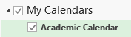

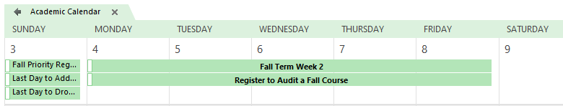
- If you want to see the Academic Calendar in the same tab as your regular calendar, right click on Academic Calendar and select “Overlay”
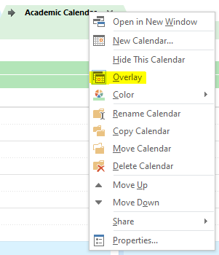

Instructions for Outlook (web version)
- Go to your Outlook calendar (outlook.office.com)
- Click “Add Calendar” (located after the month view on the left-hand side panel)
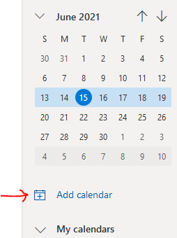
- Click “Subscribe from web”
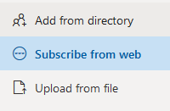
- Copy and paste the following URL into the field then click “Import”
https://outlook.office365.com/owa/calendar/dbd6d704d32c40c29b6ca42cbb5d94ba@oregonstate.edu/cef900a3a41642cbbe02b0ca25b157a99720556416781562630/calendar.ics
- Type Academic Calendar into the “Calendar Name” field
- Choose where you want the Academic Calendar to appear (or select the default Other Calendars)
- Click “Import”
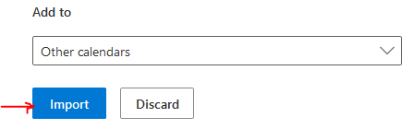
- If you see the Academic Calendar on the left-hand side panel and deadlines for the week of Oct 3, 2021, you have successfully subscribed

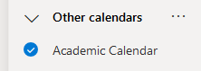

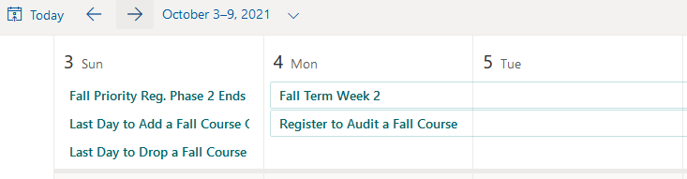
Instructions for Gmail
- Go to your Gmail calendar
- Click the gear icon in the right-hand corner then “Settings” and “Add Calendar”
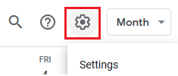
- Click “From URL” under Add Calendar
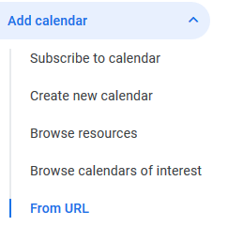
- Copy and paste the following URL into the field then click “Add calendar”
https://outlook.office365.com/owa/calendar/dbd6d704d32c40c29b6ca42cbb5d94ba@oregonstate.edu/cef900a3a41642cbbe02b0ca25b157a99720556416781562630/calendar.ics
- If you see the Academic Calendar on the left-hand side panel, you have successfully subscribed and the deadlines should show in your calendar
